1960's Web Quest - That Was Then, This Is Now
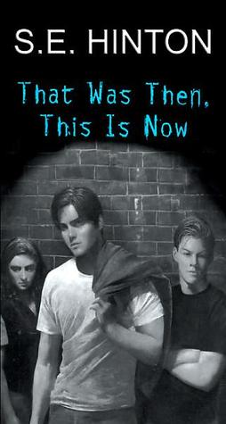

Today you will complete a Webquest based on the decade of the 60's. In That Was Then, This Is Now the novel takes place during the 1960s, an era known for music, fashion, and its culture. Below you will find directions to explore the 60s.
- Minimize the Internet and open a Microsoft Word Document. Put your name, class period, and date in the top right hand corner.
- Use the following link to search through fashion of the late 1960s. Cut and paste your favorite hairstyle and outfit into your word document.
http://www.anzwers.org/free/lisafashion/60sfashion2.html
or
http://nostalgiacafe.proboards.com/index.cgi?board=1960s&action=display&thread=118

- Under these pictures, write 4 sentences describing the outfit and hair.
- Use the following link to see pictures and descriptions of cars from the 1960s. Cut and paste the picture of the car you like best.
http://www.thepeoplehistory.com/60scars.html

- Then, write 4 sentences under the picture describing the car. Include the NAME of the car, and the PRICE the car was in 1960.
- Use Google Search Engine to search for a picture of one of the following 60's icons:
  - A young Paul Newman
  - Jimi Hendrix
  - Steve McQueen
  - Jefferson Airplane
  - Woodstock
  - The Beatles
  - American Band Stand
  - James Taylor
  - The Supremes
  - Ike and Tina Turner Review
  - Elvis Presley
  - Paste the picture in your word document and write a 4 sentence description of who and what they did.
- Hippies: Go to the following link and read to find the answered to the following questions about Hippies. Cut and paste the question into your word document and place your answer under it.

http://retrolisa.tripod.com/hippies.html

- What five things were important to hippies?

- What do you think are some reasons why a teenager might join a gang in the 60's?

WEB QUEST
1970’s

The decades of the 60’s and 70’s were as historic as any other decades in history. Below are some of the more significant events and interesting topics that made these decades special. Use the websites provided to find the answers to the questions below. This Web Quest and following links are located on my website/U.S. History/Today Unit.

1970’s: http://kclibrary.nhmccd.edu/decade70.html
Copy and paste this address into your web browser and then you will be able to pull up the file.

FADS & FASHION:

- What is a mood ring and how does it work?

- Name 4 other fads that became big in the 1970’s?

- Name 4 fashion styles of the 1970’s?

TECHNOLOGY:

- When was the “floppy disc” introduced?

- What technological device for computers was introduced during the 1970’s?

EVENTS AND PEOPLE:

Identify and explain the following important dates:

- April 22, 1970:

- May 17, 1972:

- May 29, 1972:

- September, 1972:

- 1973

EVENTS AND PEOPLE: (1970’s cont.)

- August 9, 1974:

- April 30, 1975:

- November 19, 1978:

- November 4, 1979:

MUSIC:

- What were the 5 top popular band names at this time?

THEATER, FILM, & TELEVISION:

- What were the 5 top popular movie names at this time?

