Period 4 Timeline of Major Ideas & Events (1800-1848)
Directions: Use the text and the internet to complete the following chart.
Key Concepts:
4.1: The United States began to develop a modern democracy and celebrated a new national culture, while Americans sought to define the nation’s democratic ideals and change their society and institutions to match them.
4.2: Innovations in technology, agriculture, and commerce powerfully accelerated the American economy, precipitating profound changes to U.S. society and to national and regional identities.
4.3: The U.S. interest in increasing foreign trade and expanding its national borders shaped the nation’s foreign policy and spurred government and private initiatives.

President: | Event and Significance:
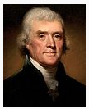  Thomas Jefferson  Democratic-Republican  (1801-1809) | Barbary Pirates (Tripoli) (1801-1805)
 | Louisiana Purchase (1803)
 | Marbury v. Madison (1803)
 | Lewis and Clark Expedition (1804)
 | Burr/Hamilton Duel (1804)
 | Chesapeake-Leopard Affair (1807)
 | Embargo Act (1807)
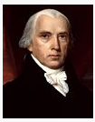  James Madison  Democratic-Republican  (1809-1817) | Nonintercourse Act of 1809
 | Macon’s Bill No. 2 (1810)
 | Fletcher v. Peck (1810)
 | Battle of Tippecanoe (1811)
 | War of 1812 (be sure to include opposition, war hawks, & major battles, as well as cause and effect)
 | Treaty of Ghent (1814)
 | Hartford Convention (1814)
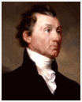  James Monroe  Democratic-Republican  (1817-1825)  James Monroe  Democratic-Republican  (1817-1825) | Era of Good Feelings (1817-1829)
 | Cultural Nationalism
 | Tariff of 1816
 | Henry Clay’s American System (1816)
 | Rush Bagot Agreement (1817)
 | American Colonization Society (1817)
 | Treaty of 1818
 | Florida Purchase Treaty (1819)
 | Panic of 1819
 | Dartmouth College v. Woodward (1819)
 | McCulloch v. Maryland (1819)
 | Adams-Onis Treaty (1819)
 | Tallmadge Amendment (1820)
 | Missouri Compromise (1820)
 | Commonwealth System (1820ish)
 | Cohens v. Virginia (1821)
 | Gibbons v. Ogden (1821)
 | Monroe Doctrine (1823)
 | “Corrupt Bargain” of 1824
John Quincy Adams  Democratic-Republican  (1825-1829)  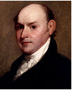  John Quincy Adams  Democratic-Republican  (1825-1829) | Erie Canal (1825)
 | American Temperance Society (1826)
 | “Tariff of Abominations” (1828)
 | American Peace Society founded (1828)
 | Revolution (Election) of 1828
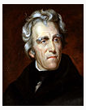  Andrew Jackson  Democrat  (1829-1837)  Andrew Jackson  Democrat  (1829-1837) | Spoils System
 | Peggy Eaton Affair (1830-1831)
 | Indian Removal Act (1830)
 | Nat Turner’s Rebellion (1831)
 | McCormick invents the Mechanical Reaper (1831)
 | Cherokee Nation v. Georgia (1831)
 | Worchester v. Georgia (1832)
 | Nullification Crisis (1832)
 | Jackson’s Bank War (1832)
 | American Antislavery Society (1833)
 | Species Circular (1836)
 | The Alamo (1836)
 | John Deere invents the Steele Plow (1837)
 | Trail of Tears (1831)
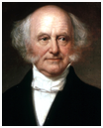  Martin Van Buren  Democrat  (1837-1841) | Panic of 1837
 | “Log Cabin and Hard Cider” Campaign of 1840
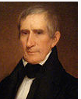  William Henry Harrison  Whig  (March 1841- April 1841)  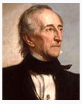  John Tyler  Whig  (1841-1845) | Irish Potato Famine (1840s)
 | Shakers (1840s)
 | Dorothea Dix and Mental Hospitals (1840s)
 | American Renaissance (1840s)
 | Brook Farm (1841)
 | Commonwealth v. Hunt (1842)
 | Webster-Ashburton Treaty (1842)
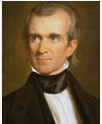  James K. Polk  Democratic  (1845-1849) | Seneca Fall Convention (1848)
 | Oneida Community (1848)

