Mr. DiCostanzo – Document Study – Manifest Destiny

Directions: Analyze the following documents and answer the guided questions following each document.

Document A

Source: America Past & Present, 2007.

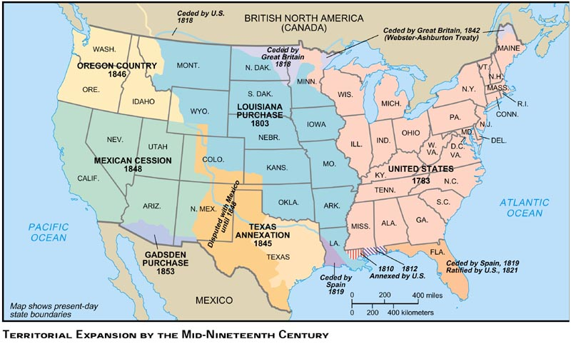

1. Write one sentence summarizing this map.
2. What territories are shown?

3. What did you find out from this map that you might not learn anywhere else?

Document B

Source: John L. O’Sullivan on Manifest Destiny, 1839.

America is destined for better deeds. It is our unparalleled glory that we have no reminisces of battlefields, but in defense of humanity, of the oppressed of all nations, of the rights of conscience, the rights of personal enfranchisement…The expansive future is our arena, and for our history…We are the nation of human progress, and who will, what can, set limits to our onward march? Providence is with us, and no earthly power can. We point to the everlasting truth on the first page of our national declaration, and we proclaim and we proclaim to the millions of other lands, that “the gates of hell”—the powers of aristocracy and monarchy—“shall not prevail against it”…Yes we are the nation of progress, of individual freedom, of universal enfranchisement…freedom of conscience, freedom of person, freedom of trade…This is our highest destiny, and in nature’s eternal, inevitable decree of cause and effect we must accomplish it…our country is destined to be the great nation of futurity…

1. Write on sentence summarizing this document.

2. What was happening at the time in history this document was created?

3. How did John O'Sullivan feel about Manifest Destiny?

Document C

Source: John Gast, “American Progress,” 1872.

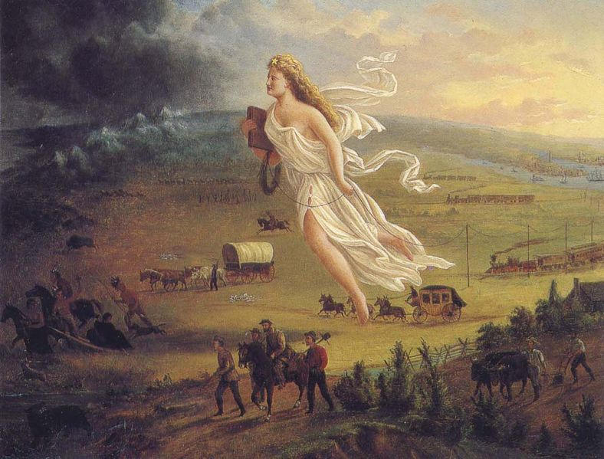

1. What does “American Progress” (this painting) by John Gast mean to you?

2. What type of “progress” is being referred to in the title of this painting?

3. What does the woman represent in this painting?

Document D

Source: James K. Polk, Inaugural Address, March 1845

Our title to the country of the Oregon is "clear and unquestionable," and already are our people preparing to perfect that title by occupying it with their wives and children. But eighty years ago our population was confined on the west by the ridge of the Alleghanies. Within that period—within the lifetime, I might say, of some of my hearers—our people, increasing to many millions, have filled the eastern valley of the Mississippi, adventurously ascended the Missouri to its headsprings, and are already engaged in establishing the blessings of self-government in valleys of which the rivers flow to the Pacific. The world beholds the peaceful triumphs of the industry of our emigrants. To us belongs the duty of protecting them adequately wherever they may be upon our soil. The jurisdiction of our laws and the benefits of our republican institutions should be extended over them in the distant regions which they have selected for their homes.

1. Write on sentence summarizing this document.

2. What was happening at the time in history this document was created?

3. How do you think President Polk felt about Manifest Destiny?

Document E

Source: Library of Congress

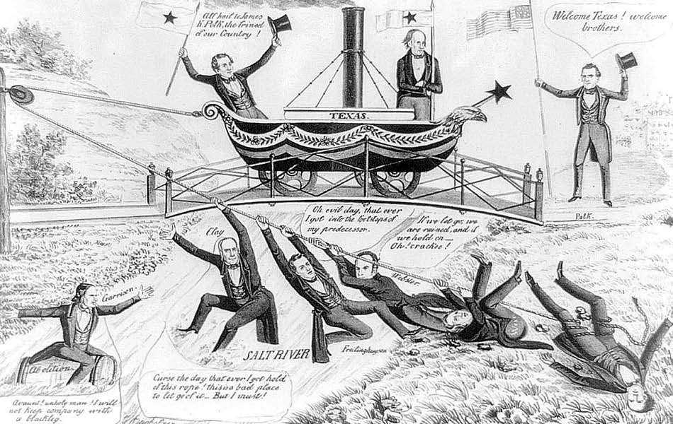

1. Quickly scan the cartoon. What do you notice first?

2. What message do you think this cartoon is attempting to convey?

3. What was happening at the time in history it was created?

Document F

Source: Speech by David Wilmot: Appeals for free soil, 1847.

But, sir the issue now presented is not whether slavery shall exist unmolested where it now is, but whether it shall be carried to new and distant regions, now free, where the footprint of a slave cannot be found. This, sir, is the issue……We are fighting this war for Texas and for the South. I affirm it - every intelligent man knows it - Texas is the primary cause of this war....
Now, sir, we are told that California is ours, that New Mexico is ours - won by the valor of our arms. They are free. Shall they remain free? Shall these fair provinces be the inheritance and homes of the whole labor of freemen or the black labor of slaves? This, sir, is the issue- this the question. The North has the right, and her representatives here have the power.

1. Write on sentence summarizing this document.

2. What was happening at the time in history this document was created?

3. What war is mentioned in the passage?

Document G

Source: Congressman Robert Toombs of Georgia, Speech in the House of Representatives, 1849.

I do not, then, hesitate to avow before this House and the country, and in the presence of the living God, that if by your legislation you [northerners] seek to drive us from the territories of California and New Mexico, purchases by the common blood and treasure of the whole peoples, and to abolish slavery in this District [Washington, D.C.] thereby attempting to fix national degradation upon half the states of this Confederacy, I am for disunion. And if my physical courage be equal to maintenance of my convictions or right and duty, I will devote all I am and all I have on earth to its consummation.

1. Write on sentence summarizing this document.

2. What was happening at the time in history this document was created?

3. What is the main issue with California and New Mexico?

Document H

Source: Library of Congress

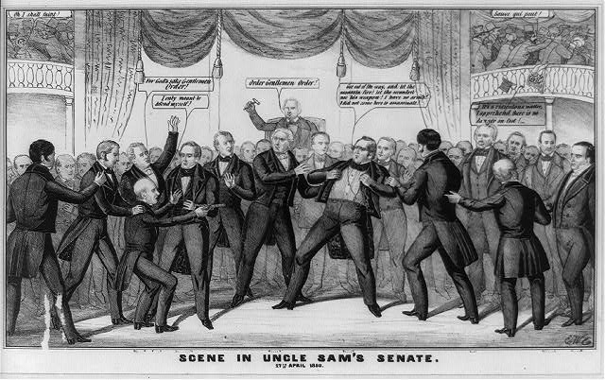

1. Quickly scan the cartoon. What do you notice first?

2. What message do you think this cartoon is attempting to convey?

3. What was happening at the time in history it was created?

Document I

Source: J.J. Warner, Report on Railroads to the California Senate, 1851

(A) railroad, from some point on the Mississippi, or its tributaries, to some point on the bay of San Francisco, is the best route that can be adopted for the purpose of securing the Commerce of China and India; . . . to open a great national highway from California to the Atlantic coast, [and] would be a greater defense and protection than all other military works. It would also be the means of great daily intercourse between the East and West coast of this Republic…to prevent those sectional feelings which have ever been the destruction of wide-extended governments…. [I]t is the duty of this Legislature to encourage the speedy building of a Railroad from the Atlantic to the Pacific, across the territory of the United States.

1. Write on sentence summarizing this document.

2. What was happening at the time in history this document was created?

3. What is the main issue with the railroads in this passage?

