Reconstruction Poster Project
You will create a Reconstruction Era Poster. Select one of the five perspectives of the reconstruction era and create a poster that accurately depicts that viewpoint: Southerner (Confederate), Former Slave, Northerner (Union), Carpetbagger, or Scalawag.
Your poster should show your understanding of the following: Goals of Reconstruction, Development of Sharecropping, Black Codes, 13^{th,} 14th, and 15th Amendments, and Economics of your part of the country after the war.
Be creative!

The poster should cover the entire paper. The attached questions will be answered within your drawings. The title of your poster should be relevant and easily detected.
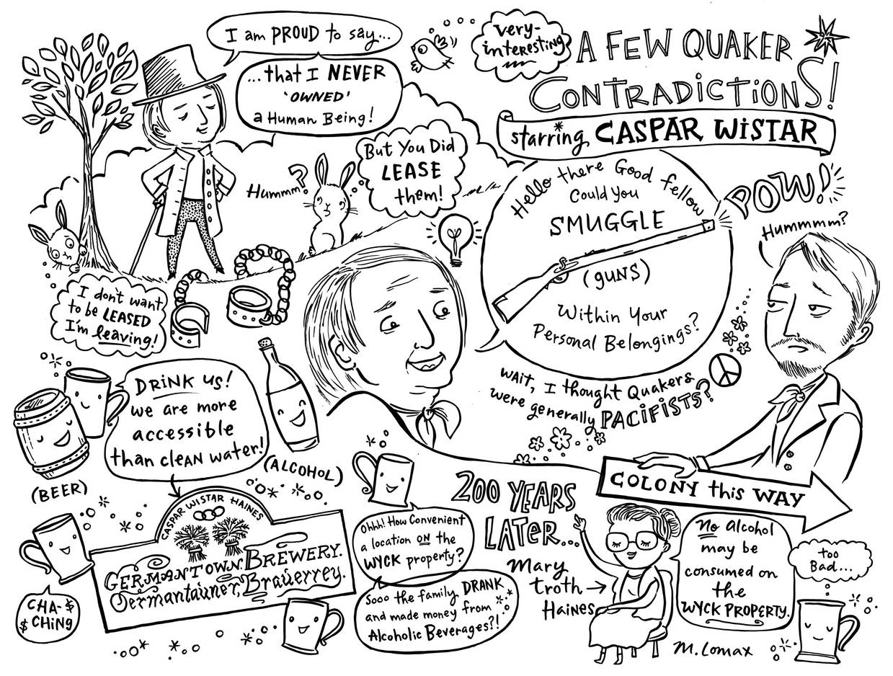
Instructions: Research your topic and answer all research questions.
Effective posters include the following elements
• Focus—the topic is clear when you first look at it.
• Main ideas—the main ideas are appropriate to the topic and presented correctly.
• Supporting Details—appropriate and accurate details support each main idea.
• Purpose—the purpose of the poster is clearly accomplished.
• Drawings and illustrations—all illustrations, photographs, graphics, and drawings add to
the purpose and interest of the poster, and can be viewed and identified from six feet away.
• Labels—all items of importance on the poster are clearly labeled with labels that can be read from at least three feet away.

Reconstruction Poster

Perspective 1: Reconstruction Plans
- Define Reconstruction.
- Dates of Reconstruction
- Lincoln’s Plan for Reconstruction
- Andrew Johnson’s Plan for Reconstruction
- Radical Republican’s Plan for Reconstruction
- Compare and contrast each plan.

Perspective 2: Freedman’s Bureau
- Define Freedman’s Bureau
- Explain the Plans & dreams of the Freedman’s Bureau.
- Explain the funding of the Freedman’s Bureau.
- Describe the successful programs of this organization.
- List the number of people helped by this organization.
- How long did the organization work?
- How did it end?

Perspective 3: Republicans
- Define Carpet Baggers.
- How many carpet baggers were there in the South during Reconstruction?
- What was the profession and reputation of the carpet baggers?
- Define Scalawag.
- Describe their role during the Reconstruction Era.
- Describe the role of African American’s in power.
- What positions did they hold?
- How many African American politicians were there in the South during Reconstruction?
- How successful were they in promoting their programs?

Perspective 4: Success and Failure of Reconstruction
- The Successes:
  - 13th Amendment
  - 14th Amendment
  - 15th Amendment
- Political Advances
- Economic Changes
- Failure of Reconstruction :
  - Economic failure in the South
  - Terror Groups : KKK , other hate groups
  - Lynching’s
  - Jim Crow Laws
  - Grandfather Clause

Perspective 5: U.S. Grant
- Reputation and the facts of the man.
- Republican Scandal
- Whiskey Ring
- Credit Mobilier
- Panic of 1873

